Testing Multiple Fails File Submissions

In testing multiple different combinations I have found that the current checks in place do NOT catch multiple fails criteria. It catches them in order of the priority in which they appear in the GameCriteria.cshtml file. The hierarchy for criteria checking is:

File Submitted

Is it a JS file?

File size

File name length

Canvas size (displayed as one element “)

So this means if a file contained all of the fail elements, for example an HTML file, whose file size was too large, had too long of a name, and an incorrectly sized canvas. Would only show as not a JS file. And so and so forth.

Because of the structure, once an error is found (for example, if no file is selected), the function returns immediately and does not proceed to the subsequent validations (like file size, file type, or canvas size checks). Therefore, only the first incorrect criteria reached is identified and displayed. Subsequent checks won't execute until earlier ones pass.

If we wanted to show multiple fails criteria, we could get rid of the immediate return statements after error checking. We could instead store the result of the check into two variables errorMessages and successMessages to display after all checks had been complete.

Below are some screenshots from some different attempts to try and trigger multiple fails criteria, with no luck:

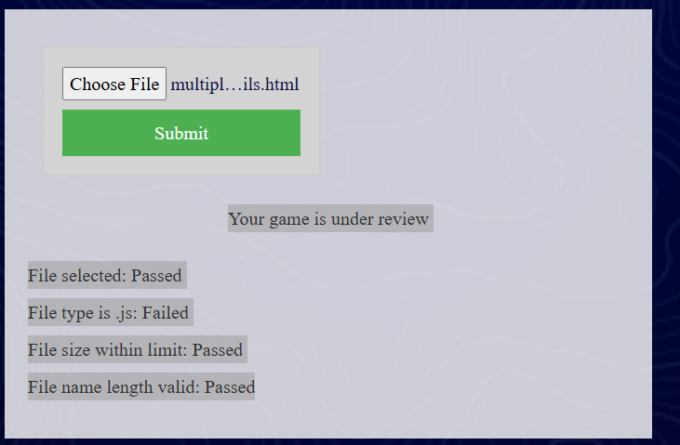

Worth noting that these are still being submitted to storage, despite failing to meet criteria:

